9V0.5A Power

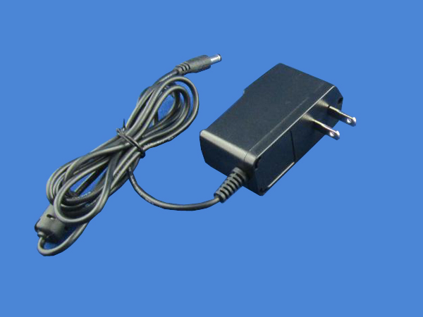
model：

input：100-240V 50-60HZ
DC connector：5.5*2.1,5.5*2.5 or other
Wire length：1.2M/1.5M
Input plug type： Europe plug or other
size：80*40*20MM
Ripple/noise：<100mVP-P
Safe protect： current overload/voltage overload /short circuit protect
Working efficiency：above 85% No – load consumption is less than 0.3W
Working temperature：0℃-40℃
High voltage：3000Vac/5mA/60s

